3D Printed Drilling Frame
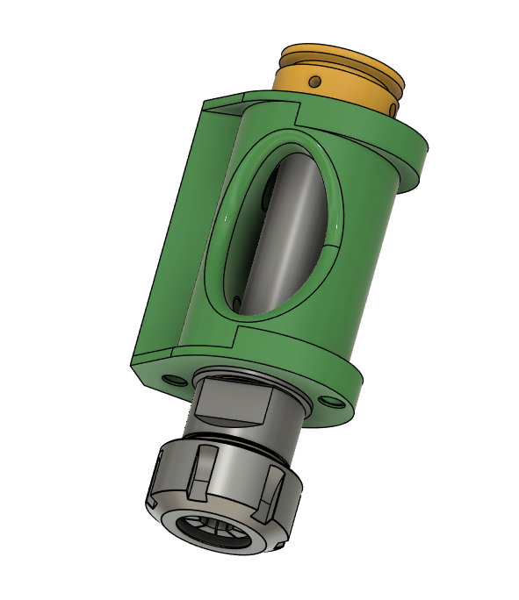

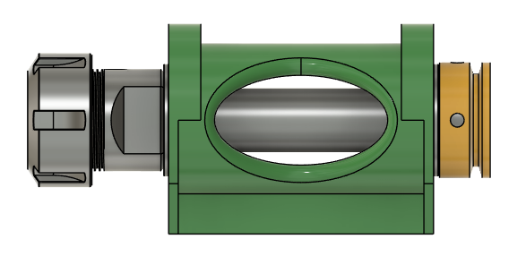

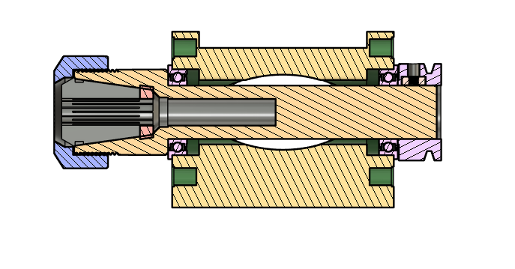
There are two 3d printed parts, the main housing (green), and the drive pulley (yellow). The housing is designed to fit in an AXA tool holder. There are two versions of the main housing, one using 32mm OD bearings, and one using 22mm OD bearings. There are three versions of the pulley, one for each shank diameter; 20mm, 12mm, and 10mm. Any ER chuck with one of those shank diameters will work. The chuck must be at least 100mm long. 150mm chucks will also work. 20mm shanks will use F6804ZZ or 6804ZZ bearings. 12mm shanks will use F6201ZZ or 6201ZZ bearings. 10mm shanks will use F6900ZZ or 6900ZZ bearings.
The pulley is secured with two 8-32 x ¼” set screw in captured 8-32 square nut
Parts List

Quantity | Description
1 | 3d printed housing
1 | 3d printed Pulley
1 | ER Chuck
2 | 8-32 square nut
2 | 8-32 x 1/4" set screw
2 | Bearings

3d Print Settings:
Setting | Value
Filament | ABS-GF
Walls | 8
Infill % | 40
Infill Pattern | Cubic
Support | Tree Slim
Brim | Outer 15mm

The file, 3D_DrillFrame.3mf, contains all of the versions. Remove the unwanted ones before printing.
